Smarthinking | Assessment 4: Individual Peer Review Reflection
Through Smarthinking you will be able to submit your assignment drafts for evaluation, which is a great opportunity to improve your writing and get useful feedback before your final submission.
As part of this course, you have been allocated 2 hours of Smarthinking time to use on Smarthinking services. These 2 hours can be used for receiving feedback on your writing for both Assessment 3 (Three Phases of Group Peer Review) and Assessment 4 (Individual Peer Review Reflection).
As part of CLIM1001/GENS0401, you are required to submit one draft of your Individual Peer Review Reflection (see below) through Smarthinking’s most comprehensive check ‘Essay Centre’. Once you receive feedback on your draft through Smarthinking, you must upload it along with the feedback onto Moodle.
Please ensure that you complete this submission no later than Sunday, Week 10.
How to Submit your Writing to the Smarthinking Essay Centre
- Log into your Smarthinking account.
- Click on ‘Submit My Writing’.
- Click on ‘Essay Centre’.
- Fill out the submission form. Copy and paste the assessment information in bold below into the corresponding fields.

Assessment 4: Individual Peer Review Reflection
Course/Unit Code, Title and Year Level:
CLIM1001/GENS0401 Introduction to Climate Change (undergrad)

Writing Title:
Individual Peer Review Reflection

Assignment Description:
This is a reflective piece of writing on the peer review process. 1000 words. No referencing required.

- You can select up to 2 areas in which you need help. For the purpose of this assessment, it is recommended you focus on ‘Content Development’ and ‘Word Choice’.
If you are submitting a second draft, you may want to change the 2 areas of feedback, so you can get the most out of the ‘Essay Centre’.

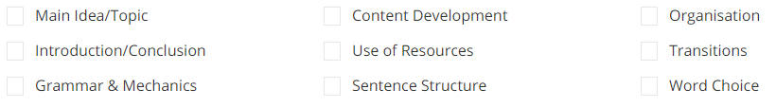
Please note that ‘Content Development’ is the development of your writing ideas and NOT course content.

- Select either ‘First Available’ or ‘ESL Specialist’ tutor, depending on your preference and need.
- Upload your essay in standard word processing formats (.doc, .docx or .rtf) and click ‘Submit’.
- Review your submissions and click ‘Confirm Submission’.

You will receive an email when your review is ready, typically within 24 hours. You can download the review from the ‘Review My Sessions and Submissions’ area found on the Smarthinking homepage.

Remaining Smarthinking Time
You have been allocated 2 hours of Smarthinking time for this course this term. To check your current balance, click on your profile name at the top of the Smarthinking homepage. Select ‘Manage Account’ and then ‘Usage Details’.
You can use your remaining time as you please. However, it is important to reflect on your areas in need of enhancement when it comes to writing and use Smarthinking to address those. Here are some further suggestions:
- If you struggle with structure/flow, you may want to use the ‘Paragraph Submission’ service.
- If you struggle with grammar/referencing, you can use the ‘Grammar & Documentation Review’ service.
- You can ask clarification questions regarding specific areas of your writing through the ‘Tutoring’ service.

Smarthinking & CLIM1001/GENS0401 Course Learning Outcomes
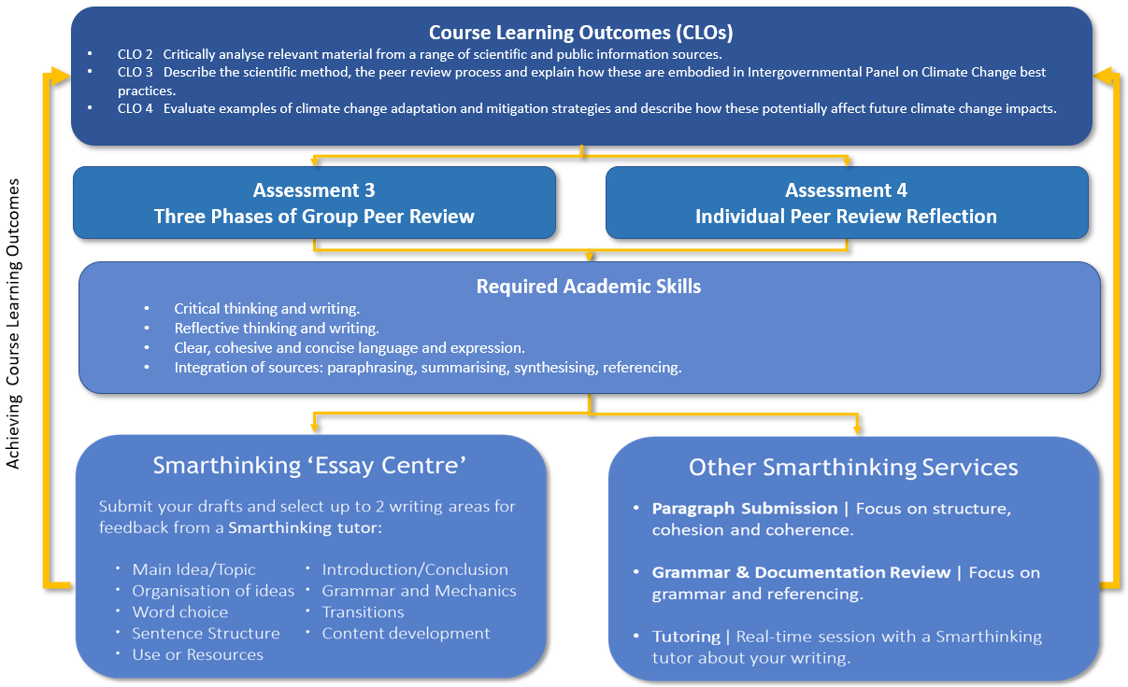
See how Smarthinking can help you achieve the Course Learning Outcomes in the following diagram.

